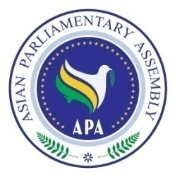

APA/Res/2008/07
29 November 2008

Resolution on
Cooperation and Coordination on
Major International Issues of Importance to APA

We, the Members of the Asian Parliamentary Assembly,

Inspired by the principles and objectives enshrined in the APA Charter and the relevant APA resolutions;

Reconfirming our determination to promote APA vision of “Flying Together toward Integrated Asia;”

Reaffirming that development of common positions and coordinated responses to major international issues constitute a fundamental prerequisite for greater integration in Asia;

Cognizant of the importance of the works of international and inter-parliamentary organizations, including the Inter-parliamentary Union;

- Decide to promote cooperation and coordination among APA Member Parliaments on major international issues, particularly those on the agenda of the IPU;

- Decide also to hold coordination meetings in a volunteer country or the country of the APA President, as necessary, and at the side of the two IPU Assemblies, in order to discuss and coordinate positions of APA Member Parliaments on major international issues of importance to APA;

- Agree that delegates to the IPU may serve, for the purpose of implementation of the relevant part of paragraph 2 above, as members of the APA in IPU Assemblies through facilitation by the APA Secretariat;

- Agree also, whenever possible, to invite relevant governmental representatives of the countries of APA in the coordination meetings referred to in paragraph 2 above;

- Request the Secretary-General to provide background information, as necessary, to the APA coordination meetings on major international issues of importance to APA on the agenda of the IPU.

